**LIST OF EQUATIONS**

**Density and Porosity Equations**

























**Thermo-physical Properties and Enthalpy Changes Calculation**





* Above Freezing Point



* Below Freezing Point













**Volume Fraction**

* Non-Porous Foods



* + Porous Foods



* Food Particles (porous and non-porous) in Bulk



**Thermal Conductivity**

* Series Model



The following equation was not included in the handout but can be also used for the series model



* Parallel Model



* Random Model



* + - EMT Model – Random Structure



* Maxwell-Eucken (M-E) Model-Random Structure



**Thermal Diffusivity**





**WATER ACTIVITY CONCEPTS**

* ****For non-ideal systems
* For ideal systems





* Moisture Sorption Isotherms

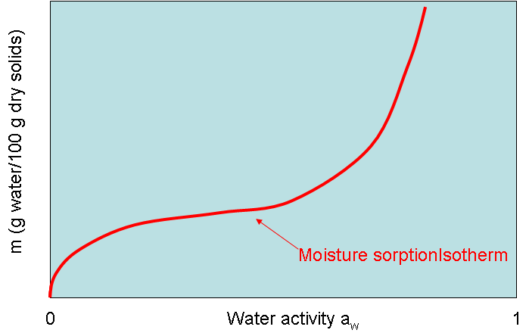

* Moisture Sorption Isotherm Models

1. BET Model





2. GAB Model



3. Peleg Model (“four” order polynomial)



* Water activity of mixtures
  + For two components



If *m1* and *m2* can be estimated by the GAB equation (and using equations *f1* and *f2*)

The equilibrium water activity of the mixture can be estimated as:



The other two models (BET and Peleg) can be used instead of the GAB equation.

* Moisture content of the mixtures

